Optical cross-correlation microscope
Ilia Platone

E-mail: info@iliaplatone.com
Abstract
This document describes a new kind of microscope, driven by a cross-correlation engine and focused by a laser or monochromatic light.
Various types of electronic microscopes exist, also kinds of microoscopes that take advantage or they working priciple basis is photon bunching. An optical and secondary X-radiation free microscope like the two-photon scanning microscope is still hard to find for small laboratories or for low budget projects.
Here we describe a static cross-correlation optical microscope, that uses a 2nd order 32 input cross-correlator and accompany software that permit zernike transormation of a sizable laser dot illuminating the specimen.

1. Setup description
The microscope system is composed by five parts, the sizable dot laser, the reflecting specimen or surface, the photon counting sensor array, the correlator, and the computer.
1.1 The sizable dot laser
The specimen must be illuminated by a laser light that can be sized so the magnification increases in function of the laser dot size, the smaller the more magnification is obtained. The laser frequency or wavelenght must be compatible or in range of the spectral sensitivity of the photon counting sensors.
1.2 The reflecting test surface
The specimen setup described in this document has to reflect the laser light, also because the kind of correlation used in this system discards the phase of the received light. Also a sample surface can be used to test its roughness or flatness and since the frame rate is enough high to obtain video streams, also live observation can be done, the laser can be sized on a specific area so larger surfaces can be observed or to build mosaics.
1.3 The photon counting sensors
The spectral sensitivity of the sensors must comprehend the wavelength of the laser light illuminating the specimen, can be used, for example, photomultiplier tubes or avalanche photodiodes, silicon photomultipliers or avalanche photodiode arrays.
1.4 The correlator
The 32 inputs correlator can calculate the coherence ratios of 496 baselines at a framerate of 30FPS. This feature permits to obtain streaming pictures or a video at visual framerates, with a fast computer or a bidimensional inverse fourier transform processor.
1.5 The computer
The computer has to be fast enough in loat operation to generate an inverse fourier plane from the baseline projection pattern, a motor feedback can drive the sensors to fill the fourier plane when making longer integration captures. Since the maximum framerate obtainable can reach video like sequencing, the inverse fourier transform must be done in a shorter time than the frame time.
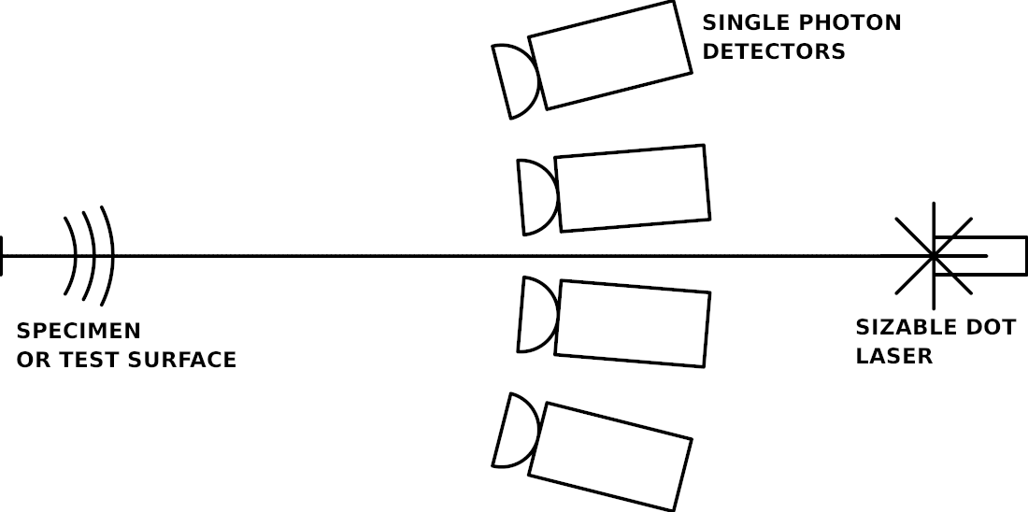Figure 1: The dark camera schematic
2. Technical description
2.1 Dark camera insulation and internal actuators
The sensor array, the laser and the test surface have to be into a light and EM insulated environment, a box, light and radiation insulated.
All communication with the sensors and laser actuators are electronical and driven by an external PC, which controls itself the various mechanics, internal of the dark camera, and displays the correlation inverse transform obtained by the correlator.
There are actuators that drive the infinite focus lenses of the laser, and actuators that occasionally drive the sensors within the dark camera.
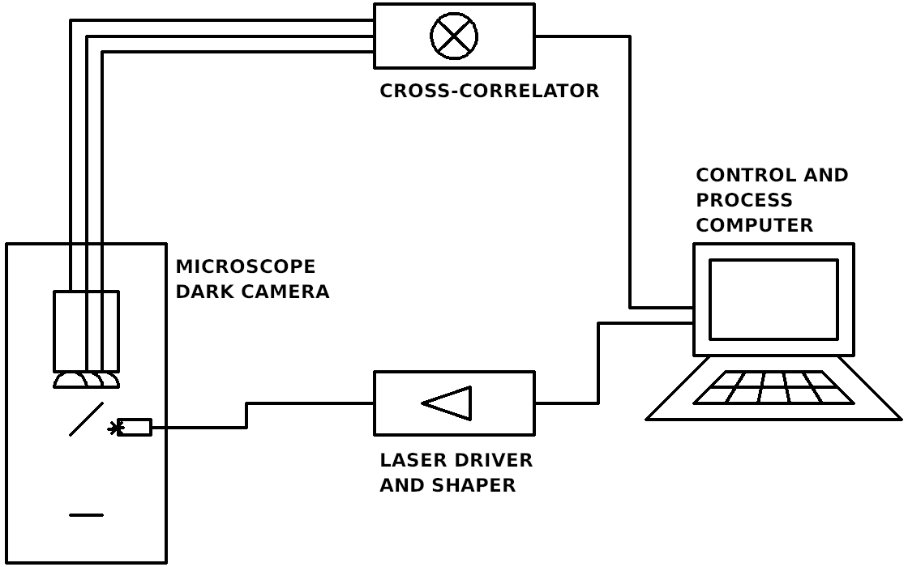Figure 2: The complete setup schematics
When making longer exposure captures, so to increase smoothness and signal-to-noise ratio by filling the UV plane, the sensors must be traslated to synthesize the aperture plane with the missing parts of the plane itself.
2.1 Dark camera insulation and internal actuators
The cross-correlator is one of the most important parts of the system.
In this document we example a 32 input cross-correlator that outputs a serial string each 30th of second with the totality of the baselines’ photon correlation counts.
With 32 sensors a total of 496 baselines can be reached.
The transmission rate of the correlator corresponds to the sampling rate and the bandwidth can reach, in commercial cross-correlator of kind, 200MHz or greater frequencies, which is enough to obtain a good SNR.
The cross-correlator generally offer the chance to obtain the spectra of the input fluxes, so various kind of observation or techniques can be implemented with this system, like multichannel raman spectroscopy or fluorescence cross-correlating microscopy or fluorescence multichannel spectroscopy.

Future perspectives
This project is into a status of draft currently, and this is research proposal for small companies to offer an adequate response to low budget laboratories or institutes.
There are many field of application where this project can be useful or interesting for, strarting from material testing, medical industry, chemical research and affiliate research fields.

